**Name = Muhammad Junaid Saleem Qadri**

**Enrollment = 02-131202-057**

**Question : 1**

**Design:**

Using Stack Data-structure (Lifo ).

**Code:**

labrary Class

class labrary

{

static int size = 10;

String[] stack = new String[size];

int top;

public labrary()

{

top = -1;

}

public void AddBook(String name)

{

if (size < top)

{

Console.WriteLine("Shielf is Full !");

return;

}

else

stack[++top] = name;

}

public String bookIssue()

{

if (top < 0)

{

Console.WriteLine("Plz add book ");

return null;

}

else

{

return stack[top--];

}

}

public void print_Book()

{

if (top < 0)

{

Console.Write("Sorry no book in Shielf !");

}

else

{

for (int i = top; i >= 0; i--)

{

Console.WriteLine((i) + ") " + stack[i]);

}

}

}

public int count()

{

return (top + 1);

}

}

MAIN METHOD

static void Main(string[] args)

{

labrary Programming_shielf = new labrary();

labrary database_shielf = new labrary();

labrary maths_shielf = new labrary();

Programming_shielf.AddBook("5329-CP-C#");

Programming_shielf.AddBook("1269-CP-java");

Programming_shielf.AddBook("8962-CP-python");

database_shielf.AddBook("6562-DB-sql");

database_shielf.AddBook("9801-DB-mysql");

database_shielf.AddBook("5841-DB-Oracle");

maths_shielf.AddBook("9541-Math-Aithmetic");

maths_shielf.AddBook("2831-Math-Algebra");

maths_shielf.AddBook("9581-Math-Geometry");

char menu = 'n';

Console.Write("1) Admin\n2) User\n\tWho are you ? ");

int user = int.Parse(Console.ReadLine());

do

{

if (user == 1)// admin

{

Console.Write("\n1) Compouter Programming\n2) Database\n3) Maths\n\tSelect any one labrary Shielf = ");

int shielf = int.Parse(Console.ReadLine());

if (shielf == 1)//CP shielf

{

Console.Write("\n\n1) Add new book\n2) See books\n\tSelect any one option : ");

int opt = int.Parse(Console.ReadLine());

if (opt == 1)

{

Console.Write("\n\nEnter Book name : ");

string name = Console.ReadLine();

Console.Write("Enter ISBN number (4 digit) : ");

int isbn = int.Parse(Console.ReadLine());

String book = String.Format(isbn + "-" + "CP" + "-" + name);

Programming_shielf.AddBook(book);

Console.WriteLine("\nYour new Book Sheilf is : ");

Programming_shielf.print_Book();

Console.Write("\n\nTotal Book in Shielf (Count) is = : ");

Console.WriteLine(Programming_shielf.count());

Console.Write("\n\n\tCan you go main menu (y/n) ? ");

menu = Convert.ToChar(Console.ReadLine());

}

else if (opt == 2)

{

Programming_shielf.print_Book();

Console.Write("\n\nTotal Book in Shielf (Count) is = : ");

Console.WriteLine(Programming_shielf.count());

Console.Write("\n\n\tCan you go main menu (y/n) ? ");

menu = Convert.ToChar(Console.ReadLine());

}

else

{

Console.WriteLine("You press Wrong key");

}

}

else if (shielf == 2)

{

Console.Write("\n\n1) Add new book\n2) See books\n\tSelect any one option : ");

int opt = int.Parse(Console.ReadLine());

if (opt == 1)

{

Console.Write("\n\nEnter Book name : ");

string name = Console.ReadLine();

Console.Write("Enter ISBN number (4 digit) : ");

int isbn = int.Parse(Console.ReadLine());

String book = String.Format(isbn + "-" + "DB" + "-" + name);

database_shielf.AddBook(book);

Console.WriteLine("\nYour new Book Sheilf is : ");

database_shielf.print_Book();

Console.Write("\n\nTotal Book in Shielf (Count) is = : ");

Console.WriteLine(database_shielf.count());

Console.Write("\n\n\tCan you go main menu (y/n) ? ");

menu = Convert.ToChar(Console.ReadLine());

}

else if (opt == 2)

{

database_shielf.print_Book();

Console.Write("\n\nTotal Book in Shielf (Count) is = : ");

Console.WriteLine(database_shielf.count());

Console.Write("\n\n\tCan you go main menu (y/n) ? ");

menu = Convert.ToChar(Console.ReadLine());

}

else

{

Console.WriteLine("You press Wrong key");

}

}

else if (shielf == 3)

{

Console.Write("\n\n1) add new book\n2) See books\n\tSelect any one option : ");

int opt = int.Parse(Console.ReadLine());

if (opt == 1)

{

Console.Write("\n\nEnter Book name : ");

string name = Console.ReadLine();

Console.Write("Enter ISBN number (4 digit) : ");

int isbn = int.Parse(Console.ReadLine());

String book = String.Format(isbn + "-" + "Math" + "-" + name);

maths_shielf.AddBook(book);

Console.WriteLine("\nYour new Book Sheilf is : ");

maths_shielf.print_Book();

Console.Write("\n\nTotal Book in Shielf (Count) is = : ");

Console.WriteLine(maths_shielf.count());

Console.Write("\n\n\tCan you go main menu (y/n) ? ");

menu = Convert.ToChar(Console.ReadLine());

}

else if (opt == 2)

{

maths_shielf.print_Book();

Console.Write("\n\nTotal Book in Shielf (Count) is = : ");

Console.WriteLine(maths_shielf.count());

Console.Write("\n\n\tCan you go main menu (y/n) ? ");

menu = Convert.ToChar(Console.ReadLine());

}

else

{

Console.WriteLine("You press Wrong key");

}

}

else

{

Console.WriteLine("You press Wrong key ! ");

}

}

else if (user == 2)//user

{

Console.Write("\n1) Compouter Programming\n2) Database\n3) Maths\n\tSelect any one labrary Shielf = ");

int shielf = int.Parse(Console.ReadLine());

if (shielf == 1)//CP shielf

{

Console.Write("\n\n1) Issue any book\n2) See books\n\tSelect any one option : ");

int opt = int.Parse(Console.ReadLine());

if (opt == 1)

{

Console.Write("\n\tYour Book is = ");

Console.WriteLine(Programming_shielf.bookIssue() + "\n");

Console.WriteLine("\nRemaining books in Shielf :");

Programming_shielf.print_Book();

Console.Write("\n\nTotal Book in Shielf (Count) is = : ");

Console.WriteLine(Programming_shielf.count());

Console.Write("\n\n\tCan you go main menu (y/n) ? ");

menu = Convert.ToChar(Console.ReadLine());

}

else if (opt == 2)

{

Programming_shielf.print_Book();

Console.Write("\n\nTotal Book in Shielf (Count) is = : ");

Console.WriteLine(Programming_shielf.count());

Console.Write("\n\n\tCan you go main menu (y/n) ? ");

menu = Convert.ToChar(Console.ReadLine());

}

else

{

Console.WriteLine("You press Wrong key");

}

}

else if (shielf == 2)

{

Console.Write("\n\n1) Issue any book\n2) See books\n\tSelect any one option : ");

int opt = int.Parse(Console.ReadLine());

if (opt == 1)

{

Console.Write("\n\tYour Book is = ");

Console.WriteLine(database_shielf.bookIssue() + "\n");

Console.WriteLine("\nRemaining books in Shielf :");

database_shielf.print_Book();

Console.Write("\n\nTotal Book in Shielf (Count) is = : ");

Console.WriteLine(database_shielf.count());

Console.Write("\n\n\tCan you go main menu (y/n) ? ");

menu = Convert.ToChar(Console.ReadLine());

}

else if (opt == 2)

{

database_shielf.print_Book();

Console.Write("\n\nTotal Book in Shielf (Count) is = : ");

Console.WriteLine(database_shielf.count());

Console.Write("\n\n\tCan you go main menu (y/n) ? ");

menu = Convert.ToChar(Console.ReadLine());

}

else

{

Console.WriteLine("You press Wrong key");

}

}

else if (shielf == 3)

{

Console.Write("\n\n1) Issue any book\n2) See books\n\tSelect any one option : ");

int opt = int.Parse(Console.ReadLine());

if (opt == 1)

{

Console.Write("\n\tYour Book is = ");

Console.WriteLine(maths_shielf.bookIssue() + "\n");

Console.WriteLine("\nRemaining books in Shielf :");

maths_shielf.print_Book();

Console.Write("\n\nTotal Book in Shielf (Count) is = : ");

Console.WriteLine(maths_shielf.count());

Console.Write("\n\n\tCan you go main menu (y/n) ? ");

menu = Convert.ToChar(Console.ReadLine());

}

else if (opt == 2)

{

maths_shielf.print_Book();

Console.Write("\n\nTotal Book in Shielf (Count) is = : ");

Console.WriteLine(maths_shielf.count());

Console.Write("\n\n\tCan you go main menu (y/n) ? ");

menu = Convert.ToChar(Console.ReadLine());

}

else

{

Console.WriteLine("You press Wrong key");

}

}

else

{

Console.WriteLine("You press Wrong key ! ");

}

}

else

{

Console.WriteLine("You press Wrong key");

}

} while (menu == 'y' || menu == 'Y');

Console.WriteLine("\n\nThanks to Using our program.....!");

}

**OUTPUT:**

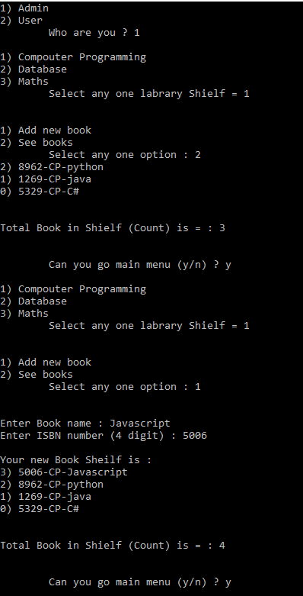 **ADMIN**

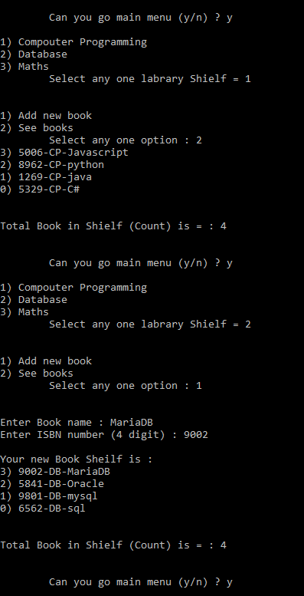

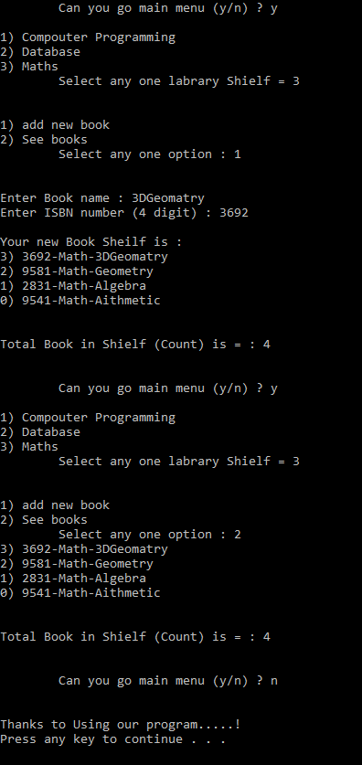

**USER**

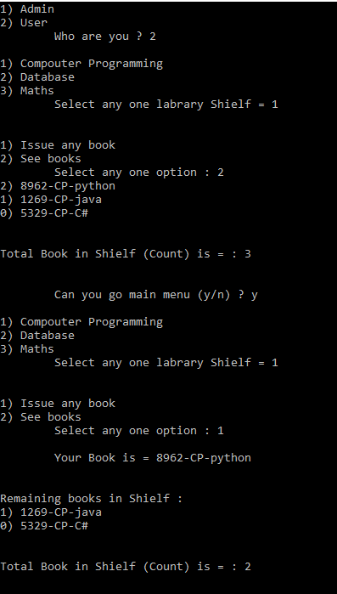

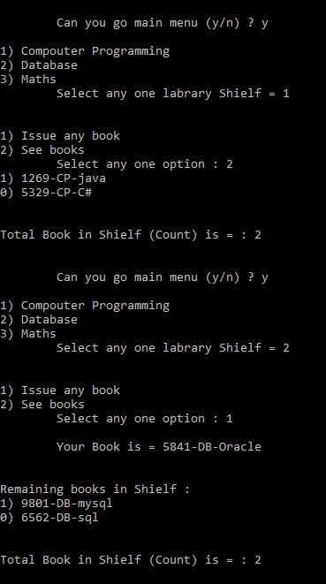

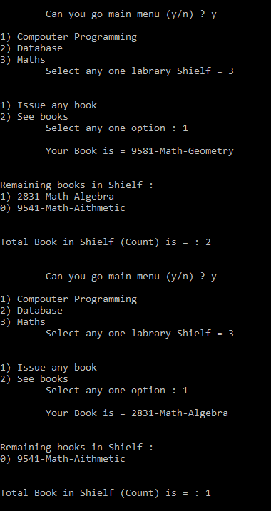

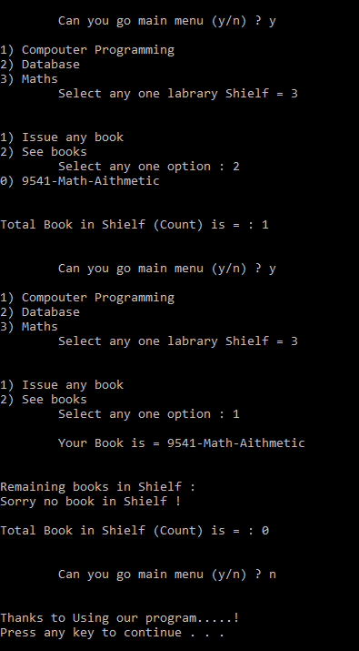

**THE END**